Artificial and Computational Intelligence Assignment 1

Problem solving by Informed Search

Problem Statement 15: Group 153

List of all the team member’s BITS ID, Name along with % of contribution in this assignment:
Sr.No | BITS ID | Name | Contribution
1 | 2024AA05735 | Nikhil Yadav | 20%
2 | 2024AA05731 | Suraj Anand | 20%
3 | 2024AA05734 | S. Hari Chandana | 20%
4 | 2024AA05732 | Ashvini Satish Bhosale | 20%
5 | 2024AA05733 | Bollam Manindra | 20%

Problem Brief:
Rohan, a new university student, must complete several admission-related tasks starting from the Admission Office and ending at the campus exit. His mission includes:
- Completing registration procedures at the Admission Office (starting point)
- Completing hostel office procedures
- Hotel facility visit
- Refreshing himself at the campus canteen
- His own department check in
- Library visit
- Exiting the campus (final destination)

Objective is to determine the most efficient route while ensuring that Rohan navigates through all the required locations exactly once, starting from the Admission Office and concluding at the campus exit. This is a path optimization problem
Given:
- The locations of the Admission Office, Hostel Office, Hostel, Campus Canteen, Department, and Library within the university campus
- The walking distances between each pair of locations
- The campus exit point
- The student's need to manage time and energy efficiently

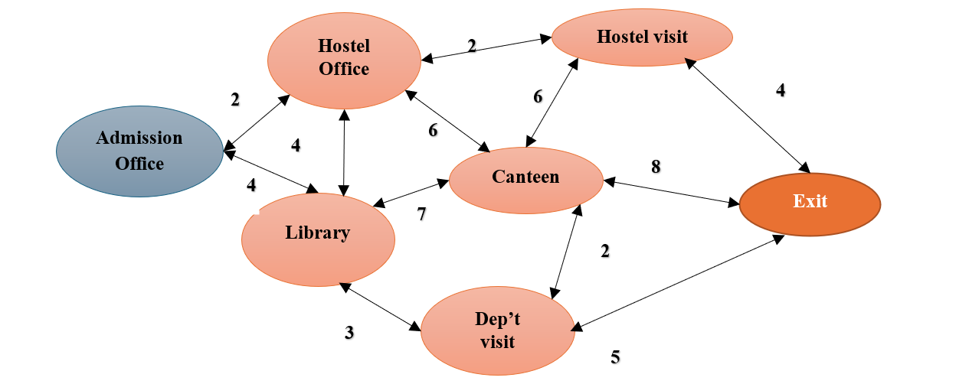

- Explain the PEAS and Task environment of the Rohan the agent in this case.

An agent in AI is any entity that perceives its environment and takes actions to achieve a goal. In this case, Rohan is an agent navigating the university campus.

1. PEAS and Task Environment
PEAS Components for Rohan’s Campus Navigation is as follows:
Component | Description
P (Performance Measure) | The goal is to find the most efficient route that allows Rohan to visit all required locations once while minimizing wal king distance.
E (Environment) | The University Campus with different locations: Admission Office, Hostel Office, Hostel, Canteen, Department, Library, and Exit. The environment includes walking paths and distances between locations.
A (Actuators) | Rohan’s movement which is walking and decision-making which is choosing the next location based on algorithms.
S (Sensors) | Rohan perceives available paths, distances, and visited locations using input (given walking distance data in the problem).

Properties of the Task Environment
Property | Description
Fully Observable or Partially Observable? | Fully Observable – Rohan knows the complete map and distances between locations.
Deterministic or Stochastic? | Deterministic – The walking distance between locations is fixed and does not change.
Episodic or Sequential? | Sequential – Each decision (which location to visit next) affects future choices.
Static or Dynamic? | Static – The environment does not change while Rohan is moving.
Discrete or Continuous? | Discrete – There are a finite number of locations and paths.
Single-agent or Multi-agent? | Single-agent – Only Rohan is making decisions.

Key Challenges in the Task Environment
- Finding the shortest path while visiting all locations exactly once.
- Time and energy efficiency – Avoid unnecessary walking.
- Handling user input – The starting location is determined by the user.

2. Heuristic & Fitness Function
A. Greedy Best First Search :
h(n) = (alpha * MST cost of unvisited nodes) + (beta * Direct cost to exit)
The Prim's algorithm is used to compute the MST cost for all unvisited nodes
alpha: Weight for MST cost component (default = 1).
beta: Weight for direct cost to exit component (default = 2).

Example Heuristic Values :
{
'Canteen': 27,
'Library': 12,
'Exit': 0,
'Hostel Office': 15,
'Admission Office': 11,
'Department visit': 24,
'Hostel visit': 19
}
B. Genetic Algorithm :

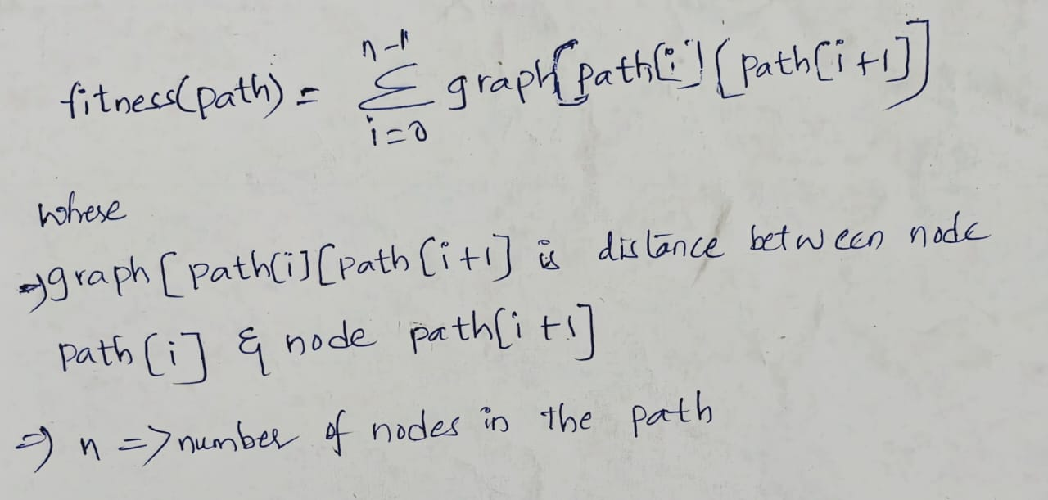
Total Distance: Sum of distances between consecutive nodes.
Invalid Path: Returns ∞ if any consecutive nodes are not directly connected.

Time & Space Complexity
Greedy Best First Search Algorithm:
Time Complexity
N = number of nodes
E = number of edges

1️. Computing Heuristics using Prim’s Algorithm
- Prim’s Algorithm Complexity: O(E log N)
- Applied to multiple nodes, leading to: O(N × (E log N))
2️. Greedy Best-First Search (GBFS) Execution
- Priority Queue Sorting → O(N log N) per iteration
- Processing Edges → O(E)
Final Time Complexity:
= O(N x (E Log N)) + O(E LogN)
= O(N x E LogN)
Space Complexity:
- Graph Storage → O(N + E)
- Priority Queue (can grow up to O(N) in worst case)
- Heuristic Table → O(N)
- Tracking Paths → O(N)
Final Space Complexity: O(N + E)
Genetic Algorithm:
Time Complexity:-
G: no of generations
P: population size
N: length of chromosome
F: time complexity of fitness function

Generating Initial Population:
Generating each individual: O(N)
Total for population: O(P * N)
Selection:
- Sorting the population based on fitness: O(P Log P)
- Selecting the top half: O(P)

Crossover and Mutation:
- Crossover for each pair: O(N)
- Mutation for each individual: O(1) (assuming constant time for swapping two elements)
- Total for new population: O(P * N)
Fitness Calculation:
- Calculating fitness for each individual: O(F)
- Total for population: O(P * F)
Total Time Complexity per Generation:
O(P Log P) + O(P) + O(P*N) + O(P*F) ≈ O(P * (N+F))
Final Time complexity:
O(P * G * (N +F))
Space Complexity:
- Storing Population:
Each individual: O(N)
Total for population: O(P * N)
Auxiliary Space:
  - Space for selected population: O(P)
  - Space for new population: O(P)
Final Space Complexity: O(P * N)

Comparison Summary:
Algorithm | Time Complexity | Space Complexity | Performance
Greedy Best First Search | O(N x E LogN) | O(N + E) | Fast but suboptimal
Genetic Algorithm | O(P * G * (N +F)) | O(P * N) | Slower but finds better path

Conclusion(Comparative Analysis or findings)
GBFS is faster but can get stuck in local optima, while GA avoids local optima but is slower due to evolutionary iterations. Using Prim's Algorithm in GBFS increases heuristic accuracy but adds computational load O(N x E LogN) whereas hop based heuristics reduces time complexity to O(E Log N).GA is more suitable for complex search spaces where an optimal solution is not easily found using heuristics alone, making it ideal for problems requiring exploration of multiple solutions.

Code Execution Flow:

Main Function ->
GetInputs()
invoke_greedy_best_first_search(graph, start_point)
greedy_best_first_search(graph, start_point, 'Exit')
compute_heuristics(graph, set(graph.keys()), goal)
invoke_genetic_algorithm(graph,start_point)
genetic_algorithm(graph, start_point, 'Exit')
generate_population(population_size, start)

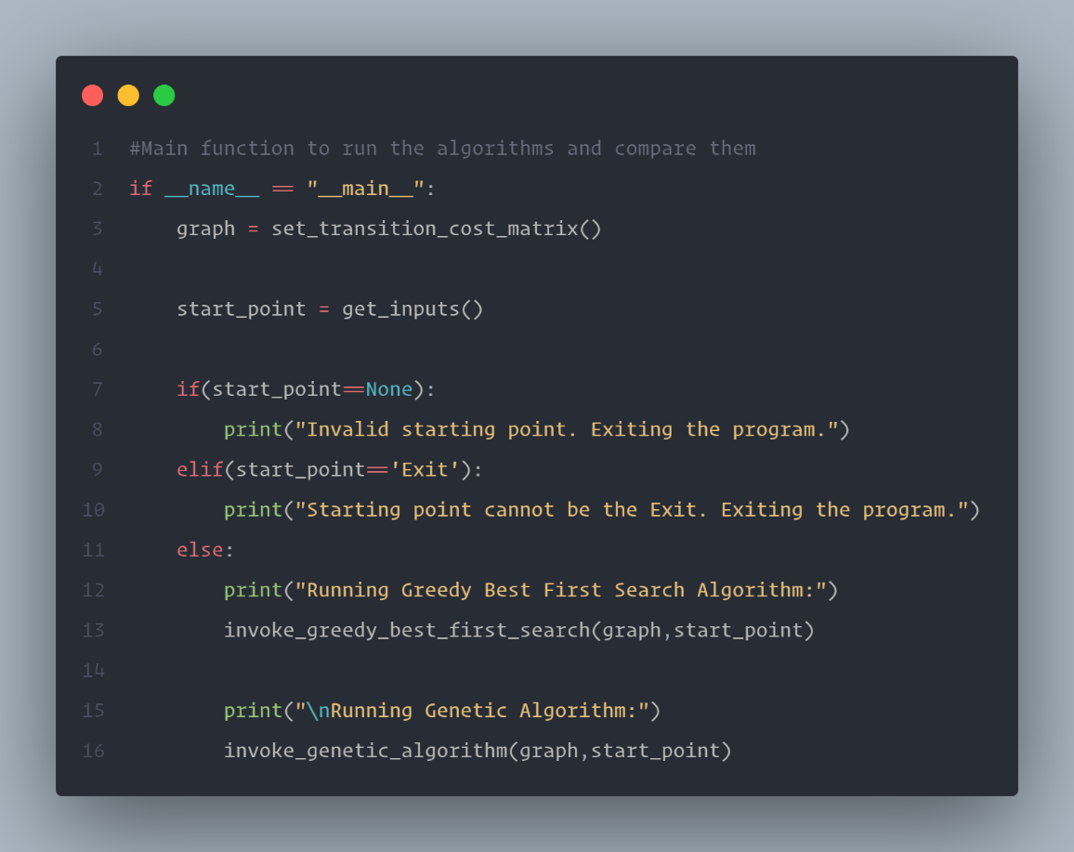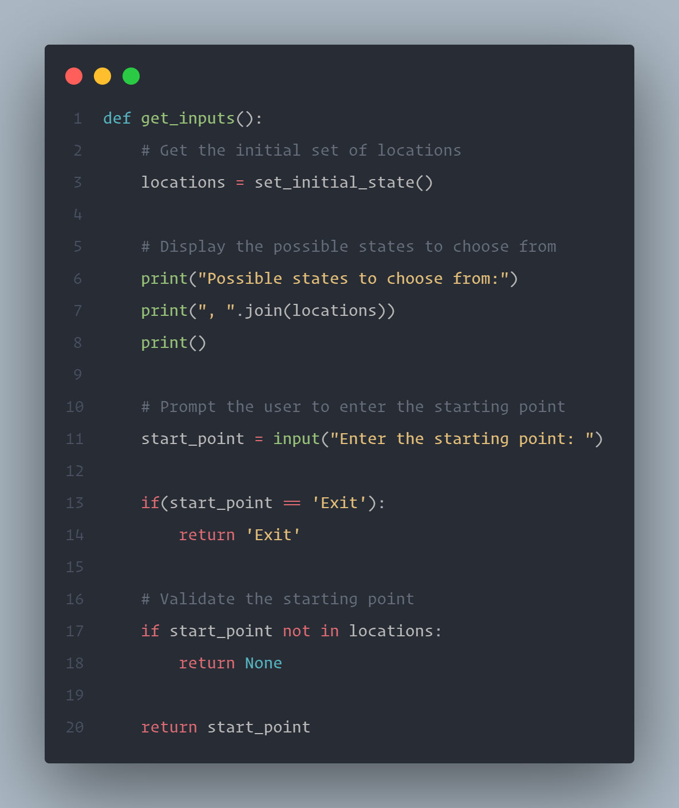

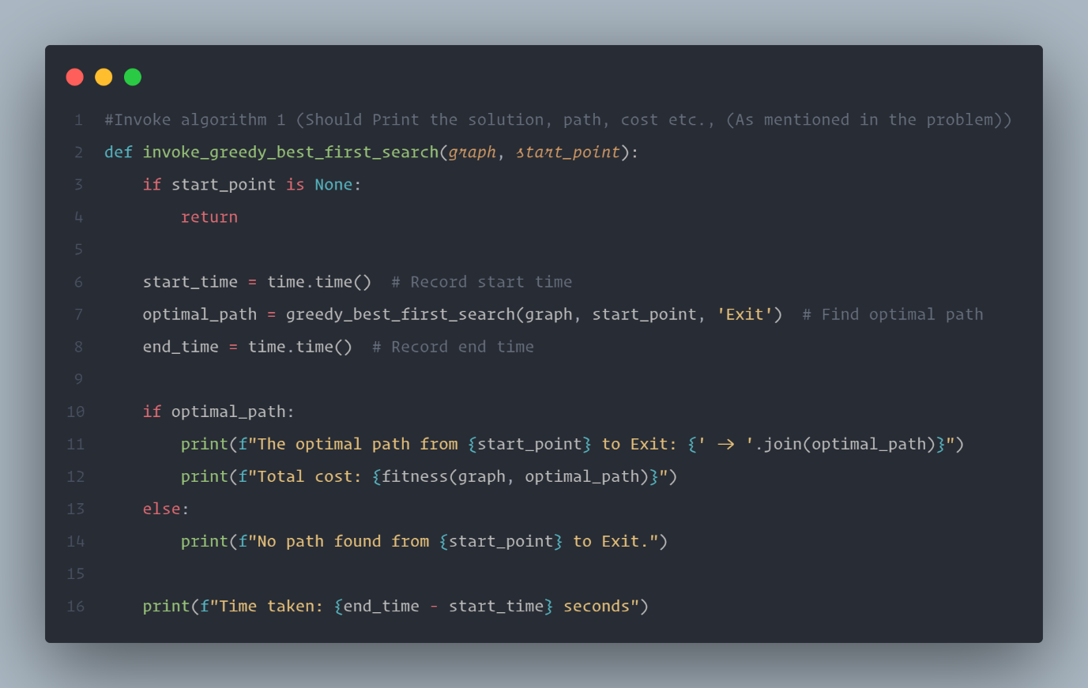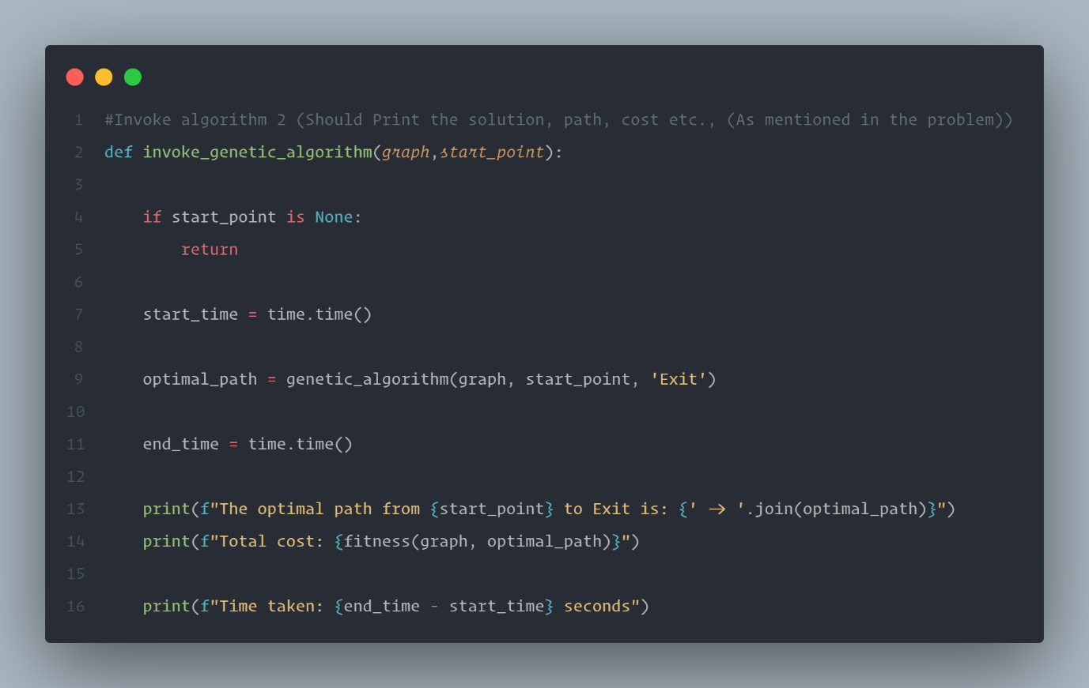
Screenshots of the Output:
(User Input can be case sensitive)
Input: ‘Admission Office’
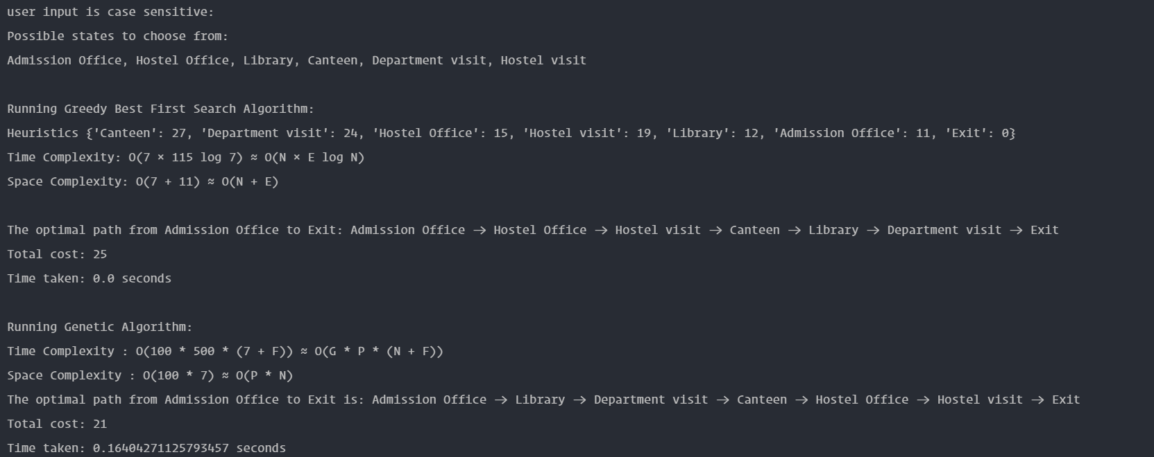

Input: ‘Library’
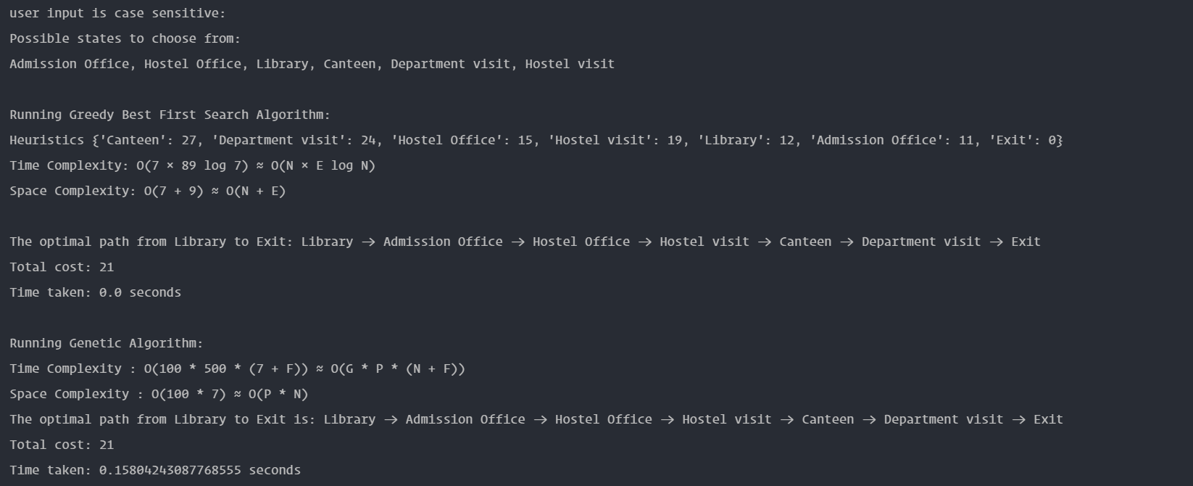

Input: ‘Exit’:


Input: Invalid or wrong inputs:


